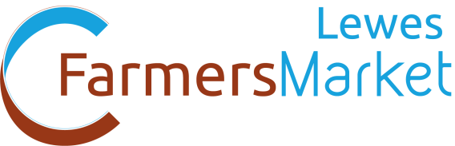
Common Cause Co-operative
111 The High Street,
Lewes, BN7 1XG
lewesfarmersmarket@gmail.com
07555 902677
Commoncause.org.uk
Criteria for Specific Products
Cheese & Other Dairy Products must be made from milk from livestock raised by the produce. Exceptions to this rule are by permission from the Market Manager
Meat must be raised by the producer from animals born and raised on the farm as sourced as young stock animals and reared to finish on the farm. Preference is given to free-range and extensive methods of production and caring animal husbandry. Intensive and battery farmed animals are excluded. Livestock should be fed non-genetically modified animal feed. (i.e. no feed containing genetically modified soya, maize, etc). A butcher may process the meat for the producer.
Game must be either reared and shot on the producers land or sourced from named local farms or estates. A butcher may process the game for the producer.
Processed Meat Products All meat in processed foods must be either raised by the producer or sourced from named local free range enterprises or from enterprises rearing animals to standards acceptable to Common Cause.
Eggs must be from animals raised by the producer on the farm. Preference is given to free-range and extensive methods of production and caring animal husbandry. Intensive and battery farmed animals are excluded. Livestock should be fed non-genetically modified animal feed. (i.e. no feed containing genetically modified soya, maize, etc).
Ready to eat food may not be sold at a stall selling raw meat.
Fish must be caught locally and names of suppliers provided. Fish products should contain wild, locally caught and landed fish. Where farmed fish is used it should be from named local enterprises that farm to standards acceptable to Common cause.
Wine, Cider & Juice must be pressed, mixed and matured from fruit grown by the producer. Exceptions to this rule are by permission of the Market Manager only.
Alcohol may only be sold if the producer obtains the relevant licence from Lewes District Council.
Plants must be grown by the producer from seeds or cuttings.
Cut Flowers must be grown & arranged by the producer.
Baked Goods must be mixed and baked by the producer. Ingredients may be purchased. Producers should use ingredients from named local producers wherever possible. Eggs used must be free-range. Priority will be given to those who use local butter, eggs, flour and other ingredients.
Preserves must be mixed, cooked and processed by the producer, but ingredients may be purchased. Major ingredients, such as the fruit for jam, or vegetables for chutney must be sourced locally. Priority will be given to those using local and environmentally grown ingredients.
Crafts must be made to a high quality out of land based or recycled materials. Inclusion in the market is at the Market Manager’s discretion.

